**PROGRAM:**

**#include <iostream>**

**using namespace std;**

**int factorial(int n) {**

**int fact = 1;**

**for (int i = 1; i <= n; ++i) {**

**fact *= i;**

**}**

**return fact;**

**}**

**int main() {**

**int n;**

**cout << "Enter the value of n: ";**

**cin >> n;**

**int sum = 0;**

**for (int i = 1; i <= n; ++i) {**

**sum += factorial(i) / i;**

**}**

**cout << "Sum of the series: " << sum << endl;**

**return 0;**

**}**

**INPUT:**

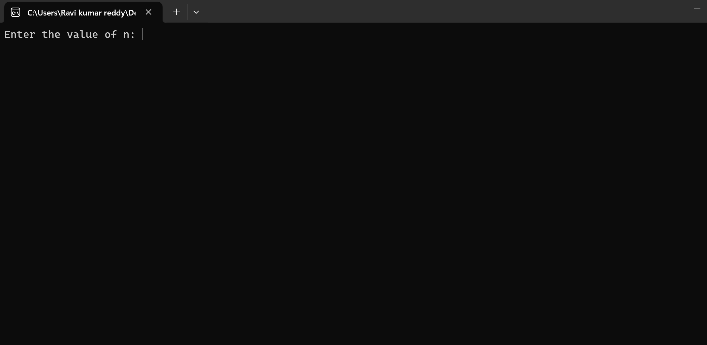

**OUTPUT:**

